# Module 10 - sqlalchemy- challenge;

Screen shots

Raj Agrawal – SMU DS / Jul2023

# Precipitation Analysis

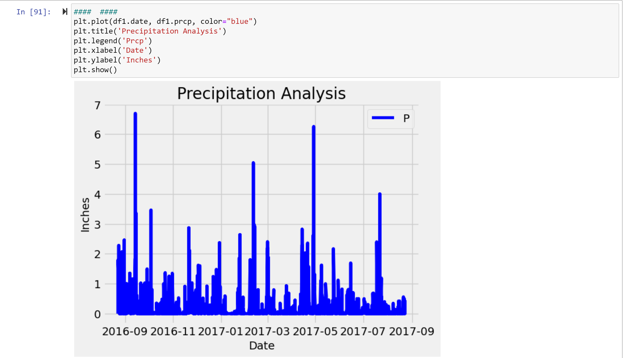

# Station Analysis

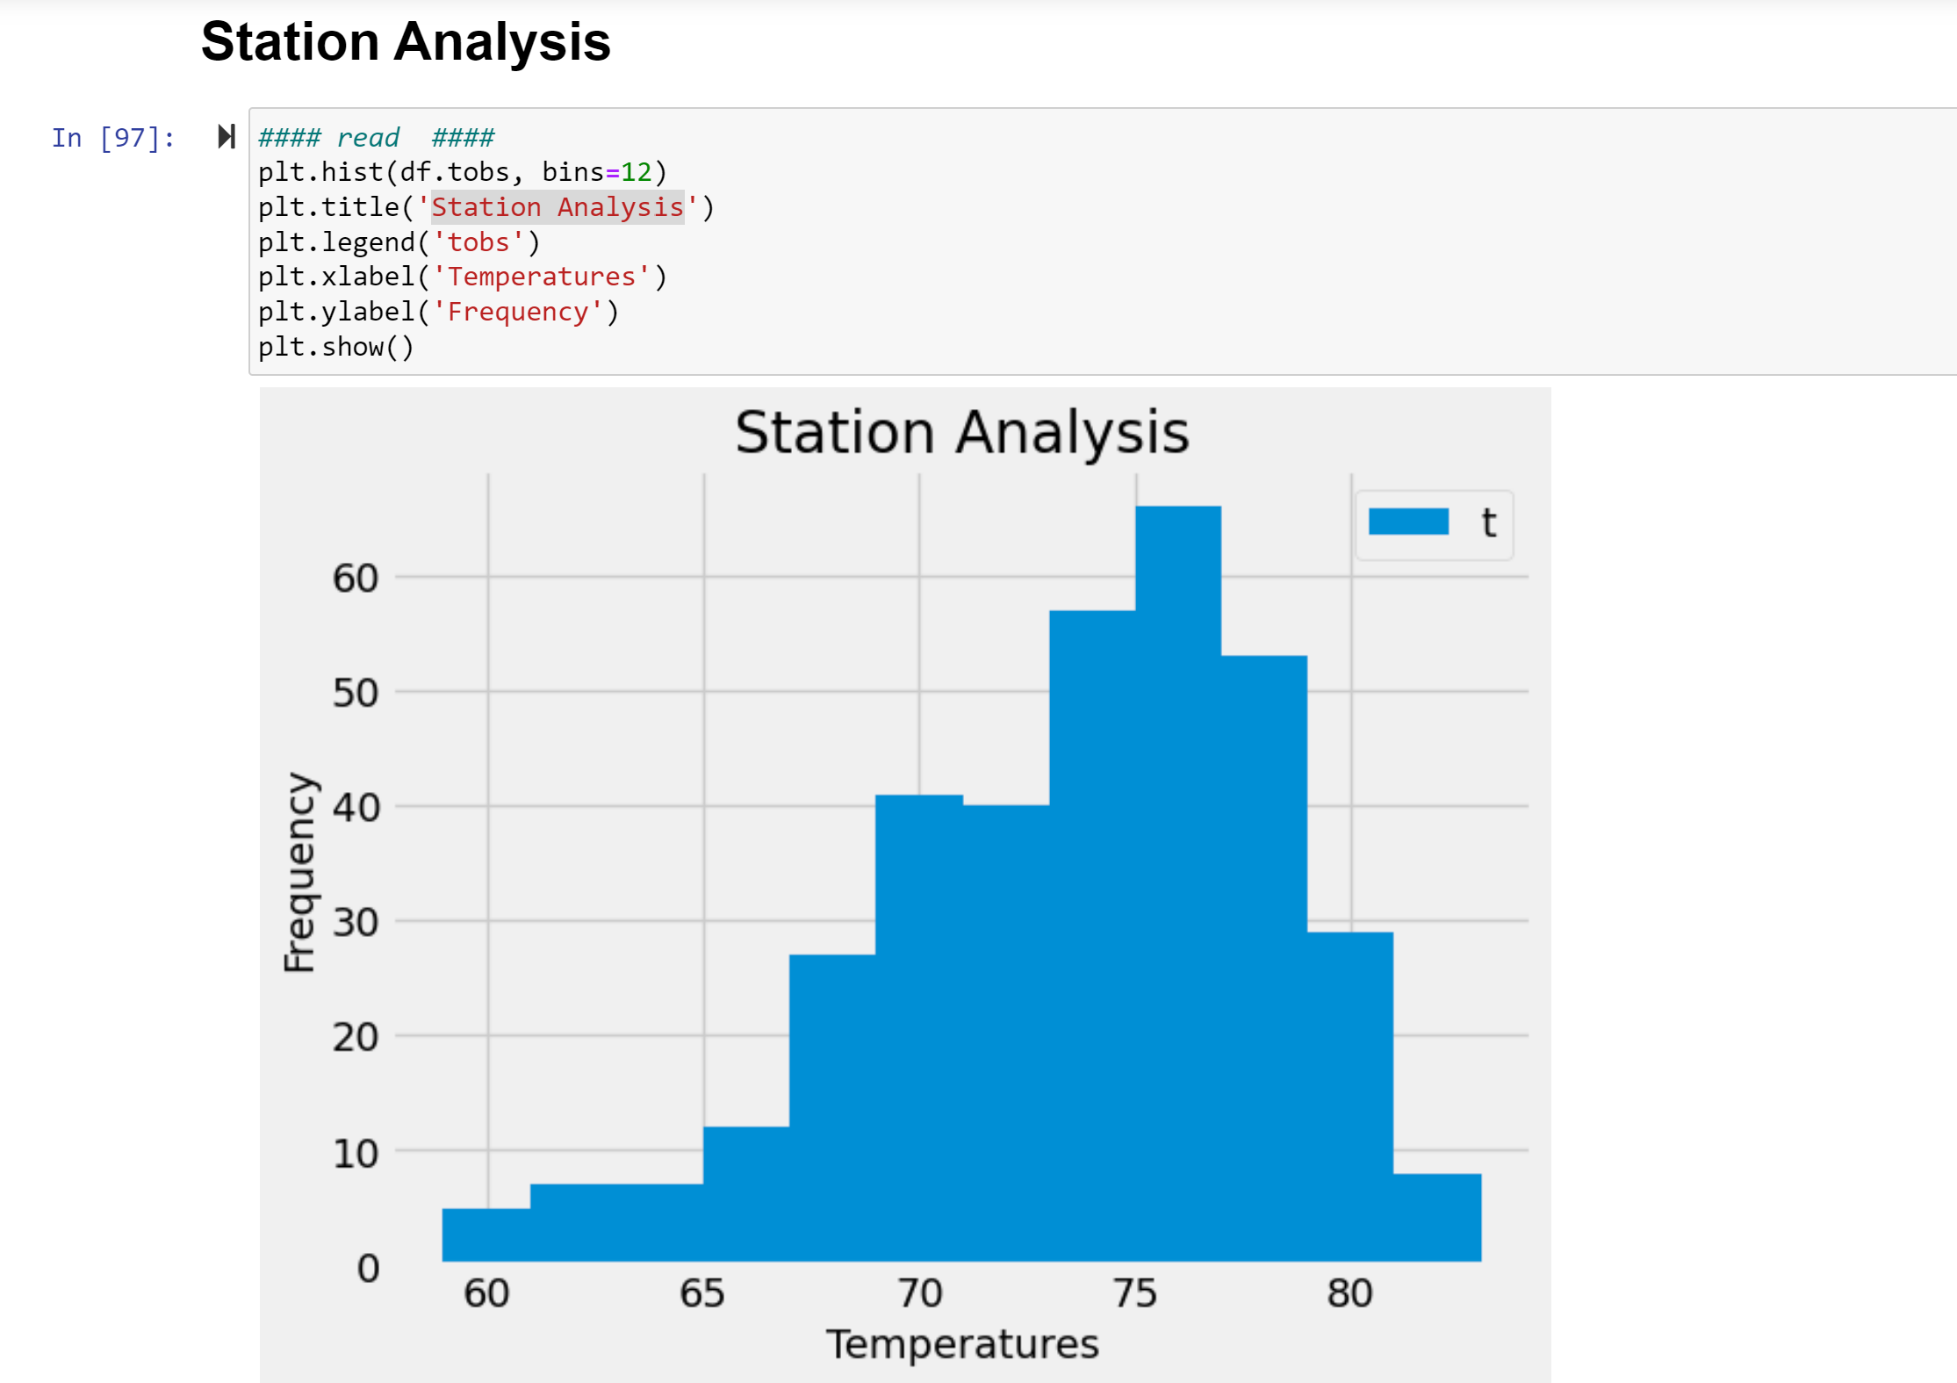

**Running flask / term output**

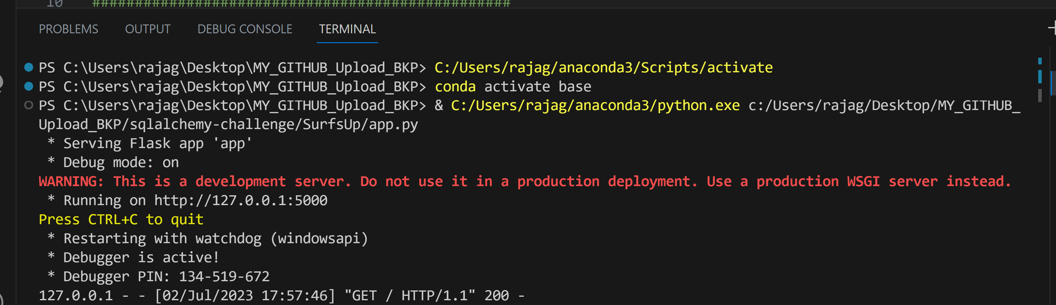

**Running flask / web output**

